Intern Name | Musaddiqa Fiaz
University / Institute | Hazara University
Internship Domain | AI Automation
Organization | Petalnex Pvt.Ltd.
Supervisor / Team Lead | Sohail Anwar
Date | 1 August 2026
DAY 2-AI AUTOMATION INTERNSHIP

SCREENSHOT OF WORKFLOW
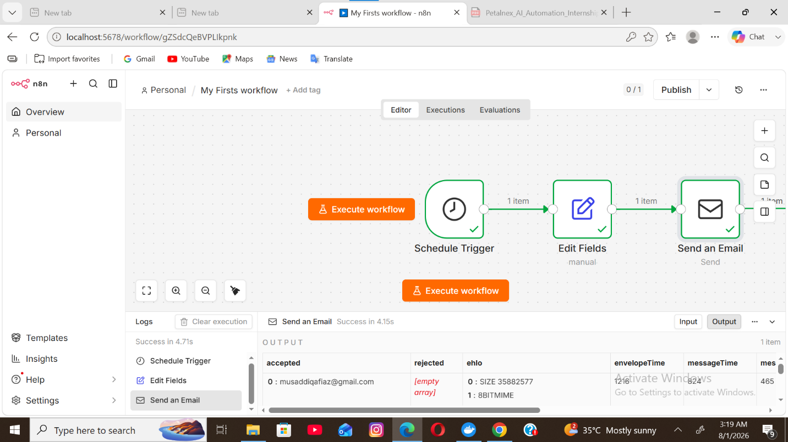

Explanation of Each Node
1. Schedule Trigger
The Schedule Trigger automatically starts the workflow at a specified time on selected weekdays. It removes the need to run the workflow manually.
2. Edit Fields (Set)
The Edit Fields (Set) node creates a data field named message and stores the reminder text. This data is then passed to the next node in the workflow.
3. Send Email
The Send Email node sends the reminder email to the specified recipient using the message created in the previous node. It uses securely stored SMTP credentials to connect to Gmail.

